

Data Structures

Experiment (7)

SID： | 242910701126
Name： | TASKIN AHMAD AL FARUQE

《Data Structures》
Title： | Minimal Spanning Tree
Experimental Environment：
Language: C++
Compiler: g++ / Visual Studio.
Operating System: Windows.
Experimental Content：

1. Concept
Two classical algorithms are used to construct an MST:

(1) Prim Algorithm
- A greedy algorithm
- Starts from a vertex and grows the MST
- Each step selects the minimum-weight edge connecting the tree to a new vertex

(2) Kruskal Algorithm
- A greedy algorithm
- Sorts all edges by weight
- Adds edges one by one without forming a cycle

2. Graph Design
- Vertices: 6
- Edges: Weighted undirected graph
- Storage structure: Adjacency matrix (Prim), Edge list (Kruskal)

Graph Data
Edge | Weight
0–1 | 6
0–2 | 1
0–3 | 5
1–2 | 5
1–4 | 3
2–3 | 5
2–4 | 6
2–5 | 4
3–5 | 2
4–5 | 6

3. Algorithm Description

Prim Algorithm
- Select a starting vertex
- Repeatedly select the minimum weight edge connecting the MST to a new vertex
- Continue until all vertices are included

Kruskal Algorithm
- Sort all edges by weight
- Select edges in increasing order
- Skip edges that create a cycle
- Stop when V-1 edges are selected

2.Code (with Comments)

Prim Algoritham:

#include <iostream>
#include <algorithm>
#include <stack>
using namespace std;

// Get operator priority
int priority(char op) {
if (op == '+' || op == '-') return 1;
if (op == '*' || op == '/') return 2;
return 0;
}

// Perform calculation
int calculate(int a, int b, char op) {
switch (op) {
case '+': return a + b;
case '-': return a - b;
case '*': return a * b;
case '/': return a / b;
}
return 0;
}

int main() {
// you can change it with any kind of expiration its depend on you. Its work as an input
string exp = "3*(3+4)";
stack<int> num; // operand stack
stack<char> op; // operator stack

for (int i = 0; i < exp.length(); i++) {
char ch = exp[i];

// If operand
if (isdigit(ch)) {
num.push(ch - '0');
}
// Left bracket
else if (ch == '(') {
op.push(ch);
}
// Right bracket
else if (ch == ')') {
while (op.top() != '(') {
int b = num.top(); num.pop();
int a = num.top(); num.pop();
char oper = op.top(); op.pop();
num.push(calculate(a, b, oper));
}
op.pop(); // remove '('
}
// Operator
else {
while (!op.empty() && priority(op.top()) >= priority(ch)) {
int b = num.top(); num.pop();
int a = num.top(); num.pop();
char oper = op.top(); op.pop();
num.push(calculate(a, b, oper));
}
op.push(ch);
}
}

// Final calculation
while (!op.empty()) {
int b = num.top(); num.pop();
int a = num.top(); num.pop();
char oper = op.top(); op.pop();
num.push(calculate(a, b, oper));
}

cout << "Result: " << num.top() << endl;
return 0;
}

Kruskal Algoritham:

struct Edge
{
int u, v, w;
};

Edge edges[] = {
{0, 1, 6}, {0, 2, 1}, {0, 3, 5}, {1, 2, 5}, {1, 4, 3}, {2, 3, 5}, {2, 4, 6}, {2, 5, 4}, {3, 5, 2}, {4, 5, 6}};

int parent[6];

int Find(int x)
{
if (parent[x] != x)
parent[x] = Find(parent[x]);
return parent[x];
}

void Kruskal()
{
for (int i = 0; i < 6; i++)
parent[i] = i;

sort(edges, edges + 10, [](Edge a, Edge b)
{ return a.w < b.w; });

cout << "Kruskal MST edges:\n";
for (int i = 0; i < 10; i++)
{
int fu = Find(edges[i].u);
int fv = Find(edges[i].v);
if (fu != fv)
{
cout << edges[i].u << " - " << edges[i].v
<< " : " << edges[i].w << endl;
parent[fu] = fv;
}
}
}

Call The main Function:

int main()
{
Prim();
Kruskal();
return 0;
}

Running Result：

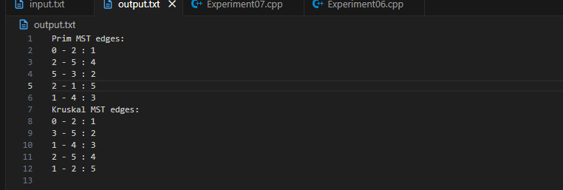

Encountered Problems：
- Avoiding cycles in Kruskal
- Selecting minimum edge efficiently
- Graph representation differences

Solutions：
- Use Union-Find structure in Kruskal
- Use visited + lowcost arrays in Prim
- Carefully design test data

